Resume

Víctor Varela was born in Ciudad de la Habana, Cuba. At the age of 17 he decided to do a career move and left his studies to dedicate his life to his passion of art. Varela, is credited as a dramatist, an actor, producer, choreographer, and director. In 1982 he majored in fine art at academy of San Alejandro, and at the same time joined “La Escuela Nacional de Teatro de Cubanacan”. In 1985 he decided to paint outside of the professional ethic, and created “Teatro Obstáculo” with the idea to paint with time. In 1997 Varela left Cuba to travel the world and returned to two-dimensional painting again in 2005.
He currently lives and works in New York and is fully dedicated to the two-dimensional painting and the theater.

EXHIBITIONS OF PAINTING
and significant events

2004
"fragment 1" Art Basel, Miami FL.
Performance.
Collective exhibition.

2005
"Fragment 2" Art Basel, Miami Fl.
Performance.
Collective exhibition.

"Fragment 3" Art Basel Miami Fl.
Performance.
Collective exhibition.

2006
• “Naturaleza abusada & hombre sin centro” Coral Gables Studio.
Collective exhibition

2007
• “Simbiosis/simbiosis” Galería Edge Zones, Miami FL.
Collective Exhibition

2007
• “Paisaje y Fuga” Dav’s Galería, Miami FL.
Single Exhibition

2007
• “Naturaleza y Música” Contemporánea Fine Art.
Single exhibition

2007
• “Motivo y Repesentacion” FIU in Art Basell.
Collective exhibition

2008
• “Sin Inocencia” Pequeño Formato. Boheme Gallery.
Collective exhibition

2009
• “Opúsculo” Brooklyn. New York.
Single exhibition

2011
“The Squares” West side Gallery. Chelsea. New York City.
Exhibition shared

2014
Catallist Gallery
Collective exhibition

2015
"The Abyss of the Birds" Frost Gallery
Single exhibition
Exhibition and performance included.
Tickets available at WWW.BROWNPAPERTICKETS.COM
Event 1777874 or The Abyss of the Birds.
Shows: Friday 23, Saturday 24 October 2015 at 8:00 pm and Sunday 25 October 2015 at 6:00 pm.
Theater seats 50 people per show.

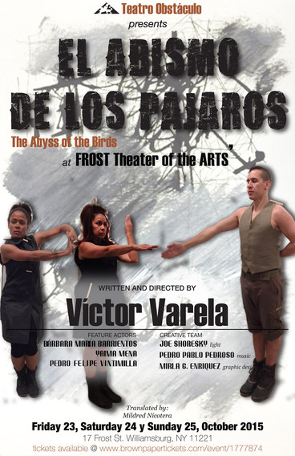

2016
"A Glimpse of Latin American Art" LATIN AMERICAN ART GALLERY. Las Vegas, NV 89117
Collective exhibition

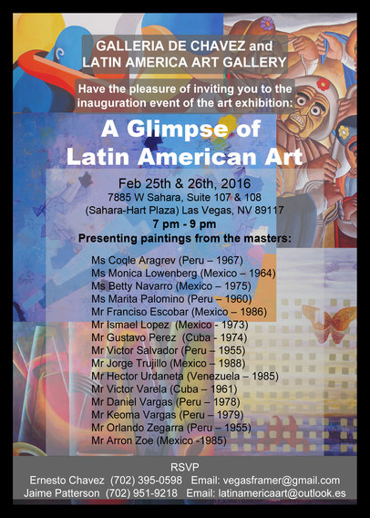

2016
"Metaphor of Colors" JADITE Galleries. 413.W 50TH St 10019 NYC
From 4 to August 26
Collective exhibition
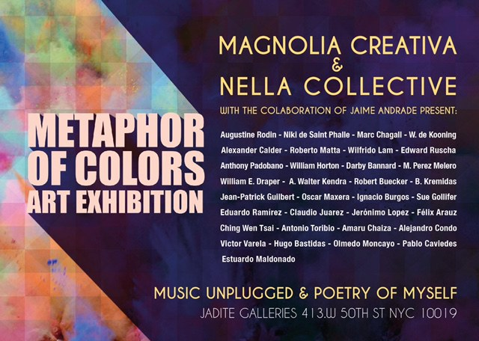

2018 Art New York
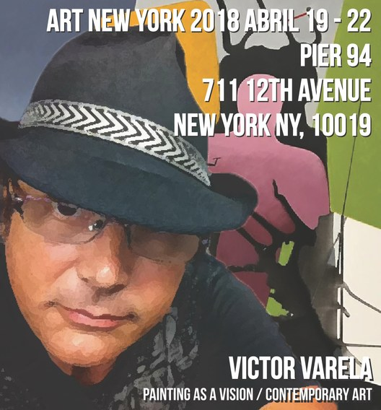

2018
La Mama Experimental Theater Club
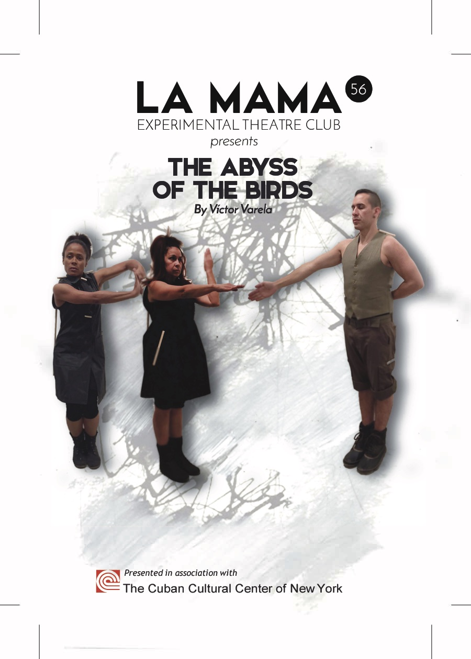

2019
Victor Varela has been selected by the Contemporary Art Curators magazine for the February 2019 edition entitled “100 artists of the future”

Contact Information:

Name: Victor Varela
Address: 37-27 79TH St 42
Jackson Heights
NY 11372
Phone number: 305 910 3296 I usually do not respond. Leave a message or send me a text message
E-mail: victor_varela@yahoo.com
Web site: victorvarelapaintings.crevado.com

